Daddy! I love you 3000 times!

Name: Nguyễn Hà Xuân Linh
ID: 175060278
Class: 17D1TA02
Faculty: English

Dear Daddy - The super hero of my morld,

I know you’re surprised this moment and may burst into tears when you hold the letter from me, your beloved daughter. And I guess, you gaze out of wonder at these words and ask yourself: “Why did she do this?” and “What is this letter about?” cause you have never seen me doing something stupid like this before.

You know, yesterday I came to know about an important upcoming day from FB and it is Father’s Day. At that very moment, I panicked and my mind was all wandering around, thinking about you. As a daughter, I’ve never done anything meaningful for you to celebrate Father’s day. You even haven’t received presents on that special day from me to boast about like other fathers out there. Daddy! As you once told me, it is never too late to do something lovely for our loved ones. I am not a great person who can do great things so I start to do tiny ones but for me they are super meaningful. Thinking of this, I got down to writing this.

My Daddy

I can just say “thank you” to you for raising me this well. Thank you for teaching me the useful lessons about life. They always come useful for me all through my life and help me become who I am today. Not everyone is lucky to have such a caring father. I’m so thankful for having you in my life. You have never given up on me despite the fact that I have been regarded as a rebellious slothful girl since I was young.

Thank you for always standing by my side. It stands to reason that the older I am, the more objections I surmounted by in work and study. Whenever I feel stressful or heartbroken, you are always there for me. From time to time when I encounter obstacles or difficulties, I have you to turn to. You have given me wise advice. You are like a guiding star, which I could instantly follow without a second thought. Although you are always busy and exhausted with your own work and other concerns, you try to spare time to listen to my difficulties and give me the endless support.

I owe you your willingness to sacrifice everything for me. When I get home from work or from university, I am given my comfort food whose ingredients include your love and sweetness. Those tiny things really make my day. You always take the best care of me by all means although I’m not a kid anymore.

After all, I just want to shout out:
爸爸我爱你很多
아빠, 많이 사랑해요~
お父さん大好きよ。
DADDY! I LOVE YOU THREE THOUSAND TIMES.

cause we seldom stand in the same picture. Here is one taken when I was a kid.

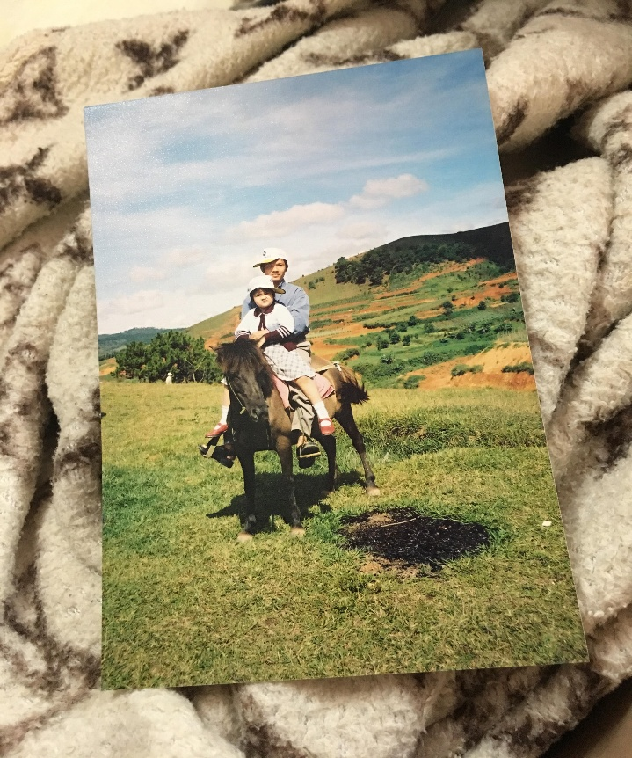

With love,

Your little daughter

